Welcome
Trinity Lutheran Church
Lutheran Church—Missouri Synod
A Stephen Ministry Congregation

1354 South Otsego Avenue
Gaylord, Michigan 49735
Church Phone: (989) 732-4816

Church Email: secretary@trinitygaylord.com
www.trinitygaylord.com

Office Hours: Monday through Friday 9am – 1pm

OUR PURPOSE
…is to LOVE GOD, LOVE OTHERS, AND SERVE THE WORLD by worshiping the Lord Jesus, bringing our members into Christ-like maturity, and equipping them through Word and Sacrament for their mission and ministry. We go heart to heart into the world with Jesus, sharing His love, caring for one another, praying, and bringing the lost into a relationship with Christ, by the working of the Holy Spirit.

February 27, 2022
The Transfiguration of Our Lord
Preacher: Rev. Ken Bernthal

ABOUT OUR WORSHIP
We welcome all who gather here today! We are blessed to celebrate together the mercy, grace, and love we have from God through the death and resurrection of our Lord Jesus Christ.

Children: Families with children are very welcome here. Having children in church is important so they can begin to learn about their faith in Jesus, and it’s good for the whole congregation to see. Please feel comfortable keeping “squirmy” kids in the service. This is where they belong, too!

Pew Cards: Guests and Members, please fill out the Guest/Member card located on the back of the pew in front of you and pass it to the end of the aisle. If you forget you can put it in the offering plate on your way out.

If standing is difficult: Please feel free to remain seated during any portion of the service. Please let an Elder or Usher know if you need communion in your pew seat.

About our celebration of Holy Communion: We celebrate the Lord’s Supper in the confession and glad confidence that, as he says, our Lord gives into our mouths not only bread and wine but his very body and blood to eat and to drink for the forgiveness of sins and to strengthen our union with him and with one another. Our Lord invites to his table those who trust his words, repent of all sin, and set aside any refusal to forgive and love as he forgives and loves us, that they may show forth his death until he comes.

Because those who eat and drink our Lord’s body and blood contrary to that which is stated above do so to their great harm, and also because Holy Communion is a confession of the faith which is confessed at this altar. Anyone who is not yet instructed, in doubt, or who hold a confession differing from that of the Lutheran Church—Missouri Synod, and yet desire to receive the sacrament, are asked first to speak with Pastor. Those not communing are still invited to come forward for a blessing from Pastor, and you may indicate this by crossing your arms over your chest.
TTTTTT

GREETING

P Peace be with you.
C And also with you.
T ORDER OF SERVICE T
(The liturgy is from Divine Service Setting four LSB pg. 203ff)

OPENING HYMN
’Tis Good, Lord, to Be Here LSB 414
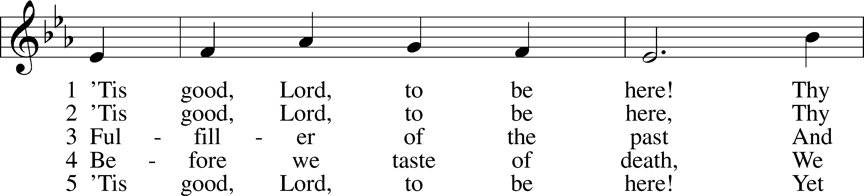
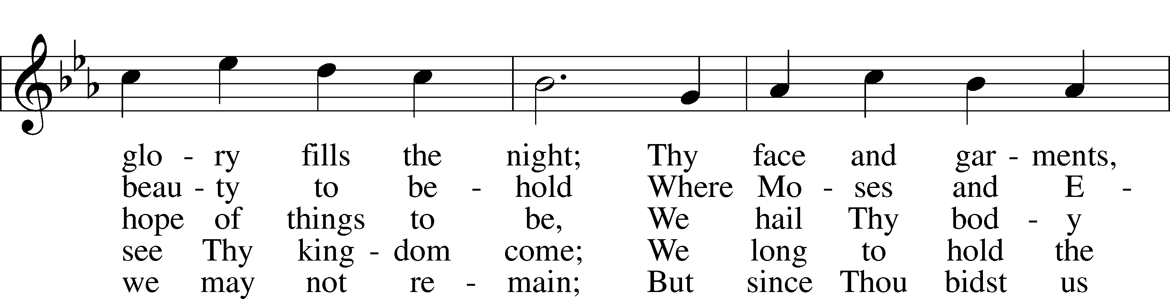
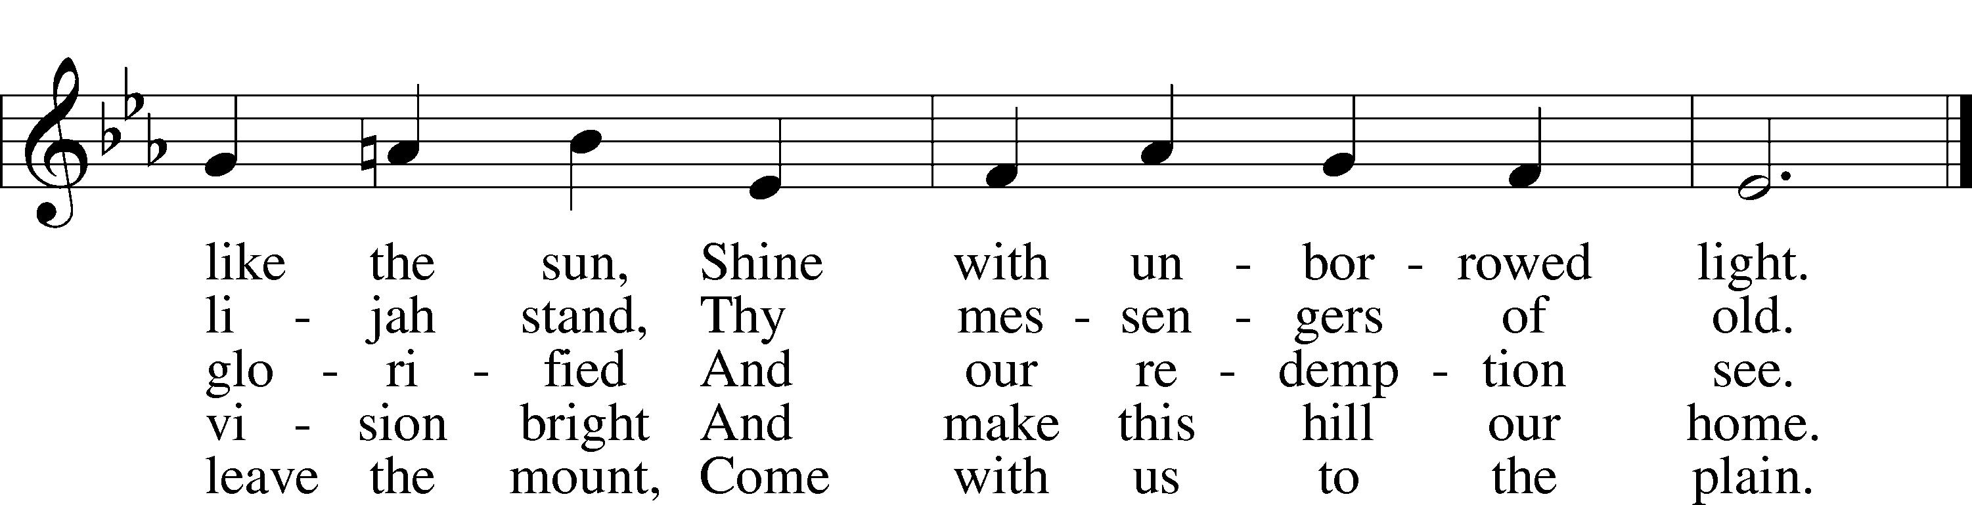
Text and tune: Public domain

Please stand as able
CONFESSION and ABSOLUTION
The sign of the cross may be made by all in remembrance of their Baptism.

P In the name of the Father and of the T Son and of the Holy Spirit.
C Amen.

P Our help is in the name of the Lord,
C who made heaven and earth.
P If You, O Lord, kept a record of sins, O Lord, who could stand?
C But with You there is forgiveness; therefore, You are feared.
P Since we are gathered to hear God’s Word, call upon Him in prayer and praise, and receive the body and blood of our Lord Jesus Christ in the fellowship of this altar, let us first consider our unworthiness and confess before God and one another that we have sinned in thought, word, and deed, and that we cannot free ourselves from our sinful condition. Together as His people let us take refuge in the infinite mercy of God, our heavenly Father, seeking His grace for the sake of Christ, and saying: God, be merciful to me, a sinner.
C Almighty God, have mercy upon us, forgive us our sins, and lead us to everlasting life. Amen.
P Almighty God in His mercy has given His Son to die for you and for His sake forgives you all your sins. As a called and ordained servant of Christ, and by His authority, I therefore forgive you all your sins in the name of the Father and of the T Son and of the Holy Spirit.
C Amen.

SERVICE OF THE WORD
INTROIT Psalm 84:1–2, 9, 11; antiphon: v. 4
P Blessèd are those who dwell in your house,
ever singing your praise!
C How lovely is your dwelling place,
O Lord of hosts!
P My soul longs, yes, faints for the courts of the Lord;
my heart and flesh sing for joy to the living God.
C Behold our shield, O God;
look on the face of your anointed!
P For the Lord God is a sun and shield; the Lord bestows favor and honor.
No good thing does he withhold from those who walk uprightly.
A Glory be to the Father and to the Son
and to the Holy Spirit;
as it was in the beginning,
is now, and will be forever. Amen.
P Blessèd are those who dwell in your house,
ever singing your praise!
SERVICE OF THE WORD
KYRIE LSB 204
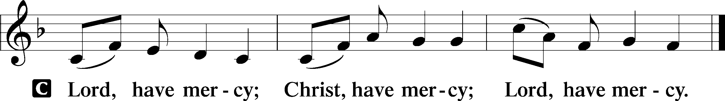

HYMN OF PRAISE
GLORIA in EXCELSIS LSB 204
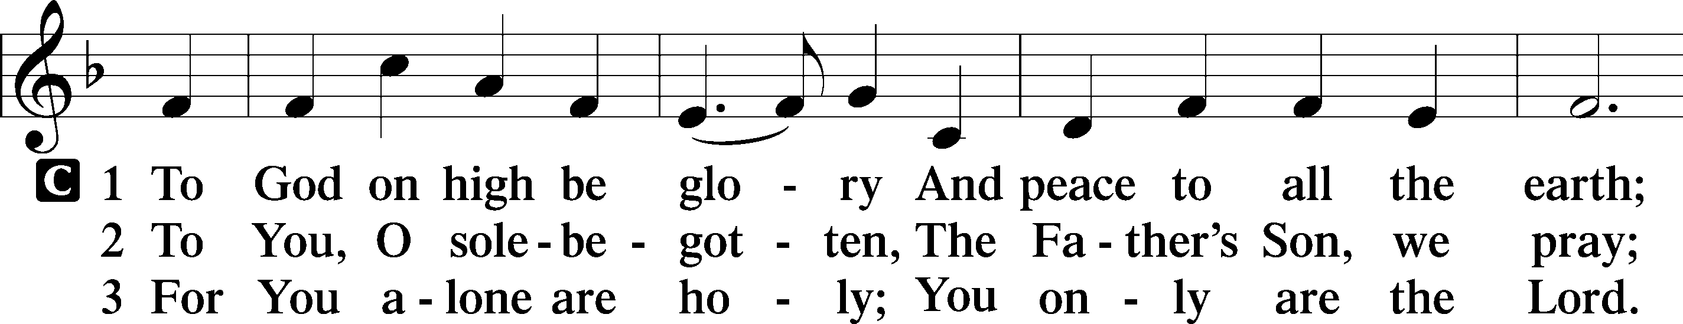
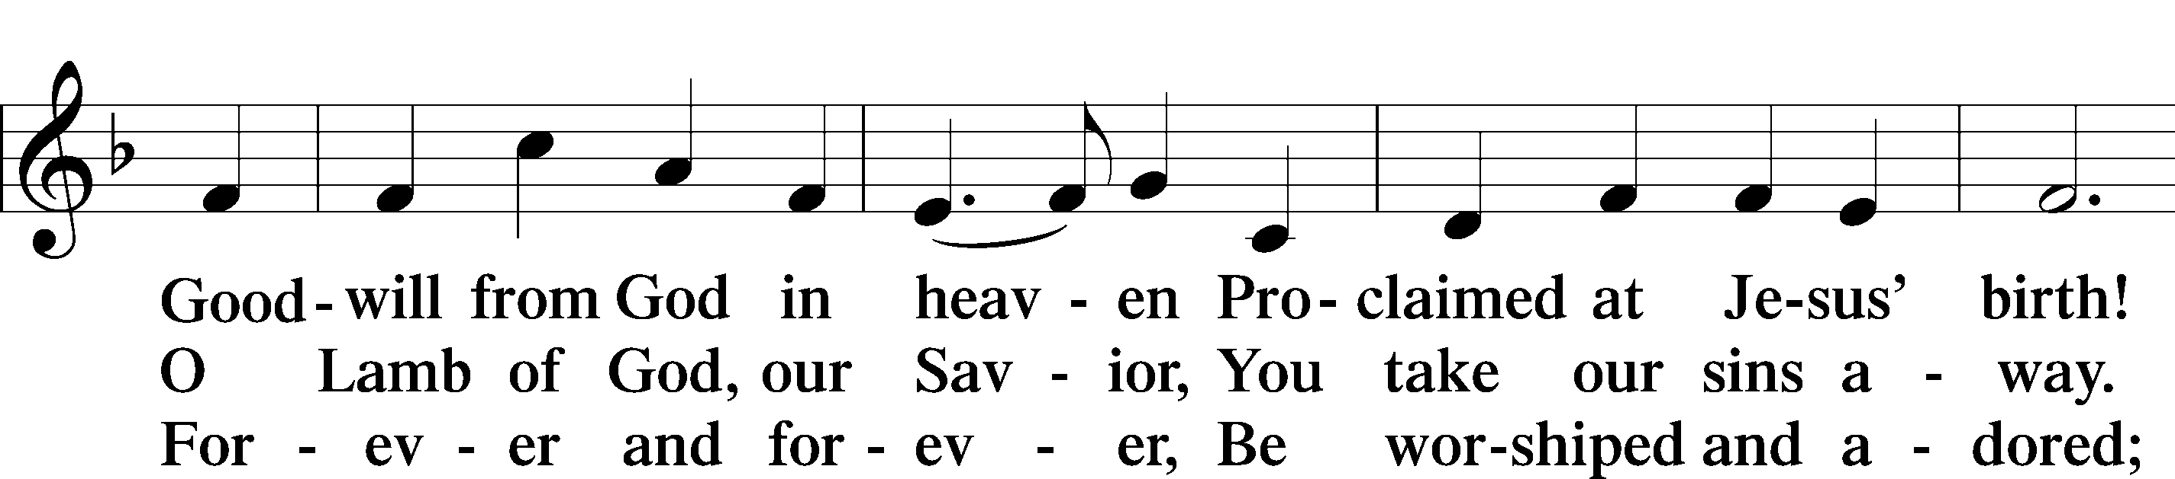
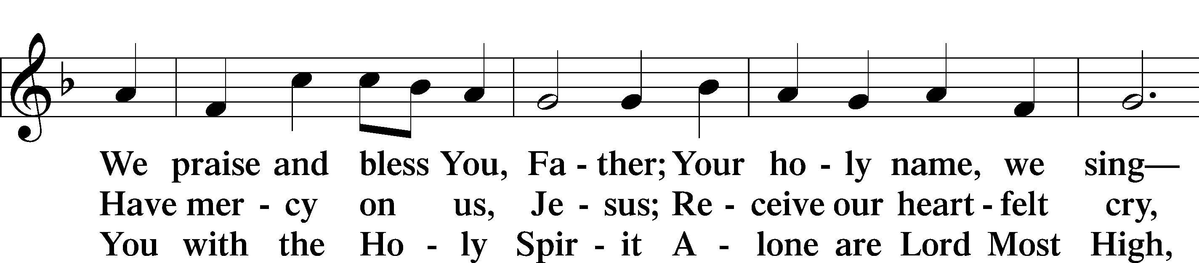
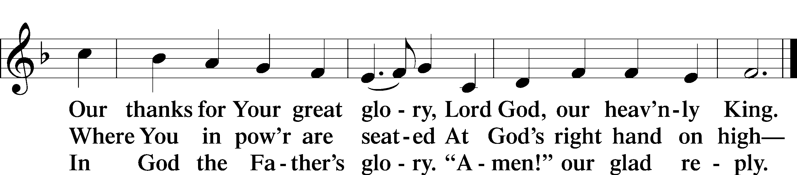

SALUTATION AND COLLECT OF THE DAY
P The Lord be with you.
C And also with you.

P Let us pray.
O God, in the glorious transfiguration of Your beloved Son You confirmed the mysteries of the faith by the testimony of Moses and Elijah. In the voice that came from the bright cloud You wonderfully foreshowed our adoption by grace. Mercifully make us co-heirs with the King in His glory and bring us to the fullness of our inheritance in heaven; through the same Jesus Christ, our Lord, who lives and reigns with You and the Holy Spirit, one God, now and forever.
C Amen.

Please be seated

OLD TESTAMENT READING Deuteronomy 34:1-12
¹Then Moses went up from the plains of Moab to Mount Nebo, to the top of Pisgah, which is opposite Jericho. And the Lord showed him all the land, Gilead as far as Dan, ²all Naphtali, the land of Ephraim and Manasseh, all the land of Judah as far as the western sea, ³the Negeb, and the Plain, that is, the Valley of Jericho the city of palm trees, as far as Zoar. ⁴And the Lord said to him, “This is the land of which I swore to Abraham, to Isaac, and to Jacob, ‘I will give it to your offspring.’ I have let you see it with your eyes, but you shall not go over there.” ⁵So Moses the servant of the Lord died there in the land of Moab, according to the word of the Lord, ⁶and he buried him in the valley in the land of Moab opposite Beth-peor; but no one knows the place of his burial to this day. ⁷Moses was 120 years old when he died. His eye was undimmed, and his vigor unabated. ⁸And the people of Israel wept for Moses in the plains of Moab thirty days. Then the days of weeping and mourning for Moses were ended.
⁹And Joshua the son of Nun was full of the spirit of wisdom, for Moses had laid his hands on him. So the people of Israel obeyed him and did as the Lord had commanded Moses. ¹⁰And there has not arisen a prophet since in Israel like Moses, whom the Lord knew face to face, ¹¹none like him for all the signs and the wonders that the Lord sent him to do in the land of Egypt, to Pharaoh and to all his servants and to all his land, ¹²and for all the mighty power and all the great deeds of terror that Moses did in the sight of all Israel.

P This is the Word of the Lord.
C Thanks be to God.

EPISTLE Hebrews 3:1–6
¹Therefore, holy brothers, you who share in a heavenly calling, consider Jesus, the apostle and high priest of our confession, ²who was faithful to him who appointed him, just as Moses also was faithful in all God’s house. ³For Jesus has been counted worthy of more glory than Moses—as much more glory as the builder of a house has more honor than the house itself. ⁴(For every house is built by someone, but the builder of all things is God.) ⁵Now Moses was faithful in all God’s house as a servant, to testify to the things that were to be spoken later, ⁶but Christ is faithful over God’s house as a son. And we are his house if indeed we hold fast our confidence and our boasting in our hope.

P This is the Word of the Lord.
C Thanks be to God.
Please stand as able
ALLELUIA AND VERSE LSB 205
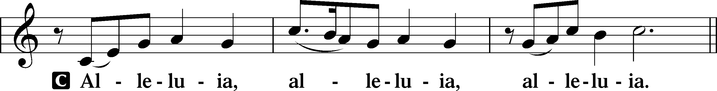

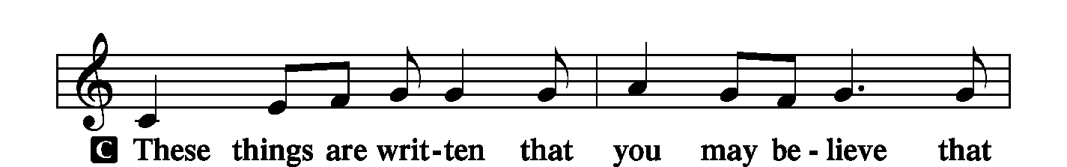
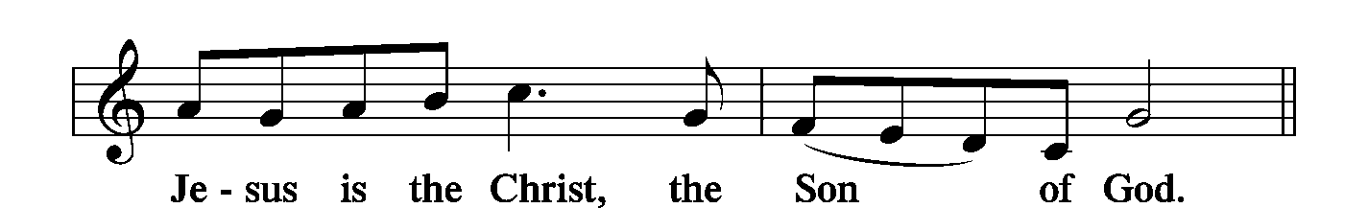
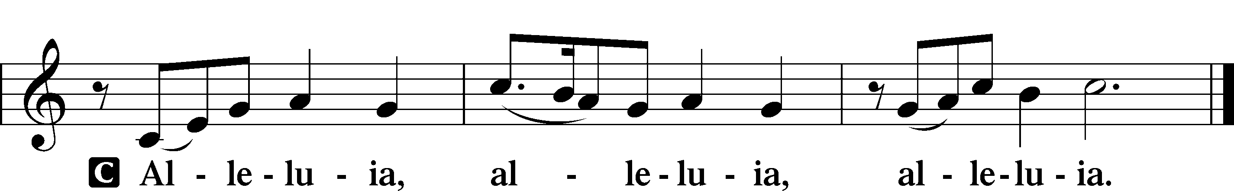

HOLY GOSPEL Luke 9:28–36
P The Holy Gospel according to St. Luke, the ninth chapter.
C Glory to You, O Lord.

²⁸Now about eight days after these sayings [Jesus] took with him Peter and John and James and went up on the mountain to pray. ²⁹And as he was praying, the appearance of his face was altered, and his clothing became dazzling white. ³⁰And behold, two men were talking with him, Moses and Elijah, ³¹who appeared in glory and spoke of his departure, which he was about to accomplish at Jerusalem. ³²Now Peter and those who were with him were heavy with sleep, but when they became fully awake they saw his glory and the two men who stood with him. ³³And as the men were parting from him, Peter said to Jesus, “Master, it is good that we are here. Let us make three tents, one for you and one for Moses and one for Elijah”—not knowing what he said. ³⁴As he was saying these things, a cloud came and overshadowed them, and they were afraid as they entered the cloud. ³⁵And a voice came out of the cloud, saying, “This is my Son, my Chosen One; listen to him!” ³⁶And when the voice had spoken, Jesus was found alone. And they kept silent and told no one in those days anything of what they had seen.

P This is the Gospel of the Lord.
C Praise to You, O Christ.

NICENE CREED
C I believe in one God,
the Father Almighty,
maker of heaven and earth
and of all things visible and invisible.
And in one Lord Jesus Christ,
the only-begotten Son of God,
begotten of His Father before all worlds,
God of God, Light of Light,
very God of very God,
begotten, not made,
being of one substance with the Father,
by whom all things were made;
who for us men and for our salvation came down from heaven
and was incarnate by the Holy Spirit of the virgin Mary
and was made man;
and was crucified also for us under Pontius Pilate.
He suffered and was buried.
And the third day He rose again according to the Scriptures
and ascended into heaven
and sits at the right hand of the Father.
And He will come again with glory to judge both the living and the dead,
whose kingdom will have no end.
And I believe in the Holy Spirit,
the Lord and giver of life,
who proceeds from the Father and the Son,
who with the Father and the Son together is worshiped and glorified,
who spoke by the prophets.
And I believe in one holy Christian and apostolic Church,
I acknowledge one Baptism for the remission of sins,
and I look for the resurrection of the dead
and the life T of the world to come. Amen.

Please be seated

ALL GOD’S CHILDREN – TALK

HYMN OF THE DAY
Faith and Truth and Life Bestowing LSB 584
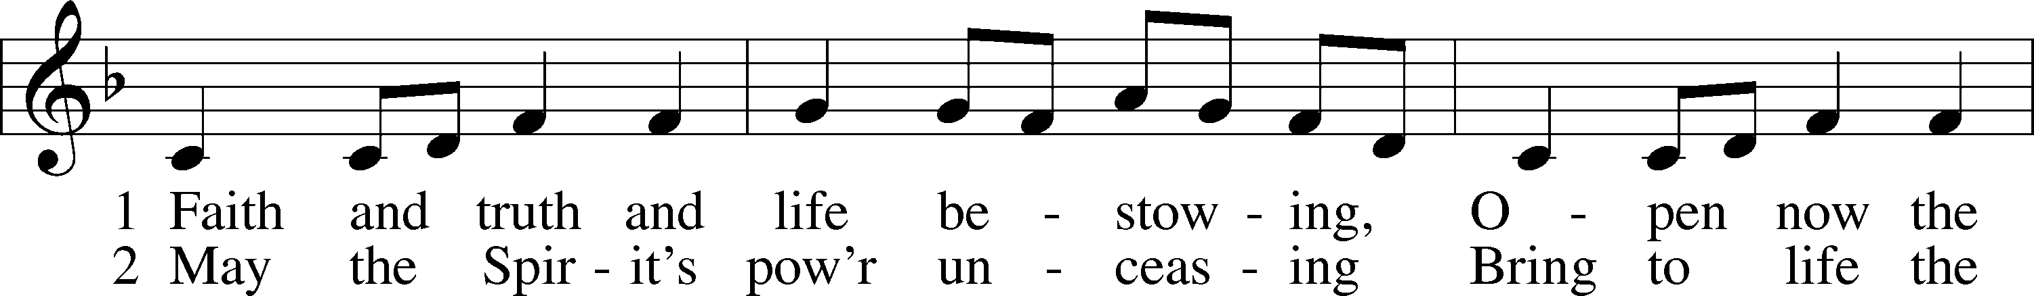
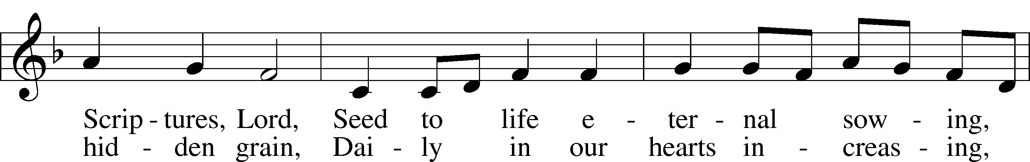
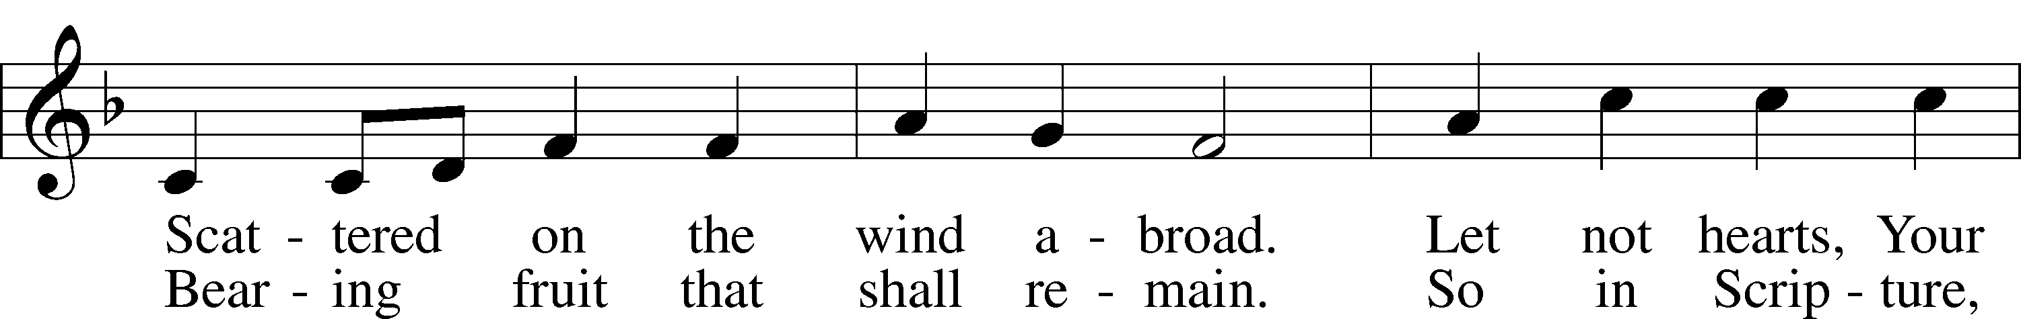
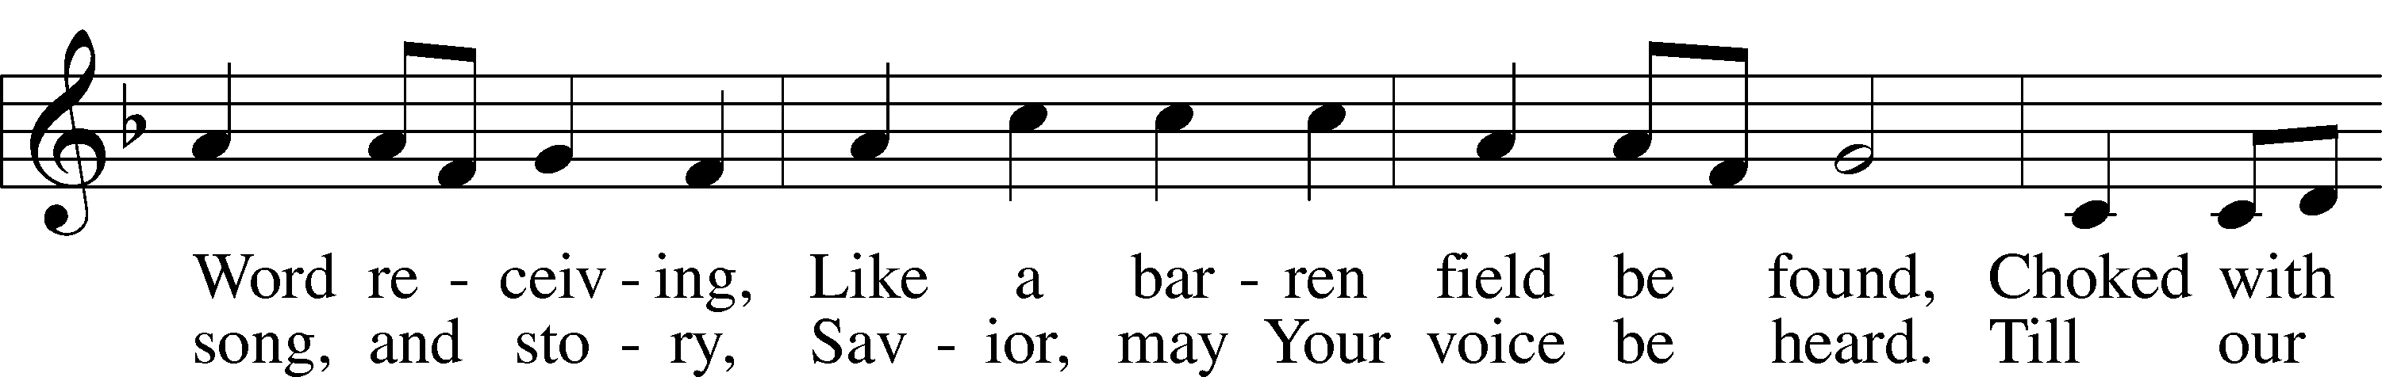
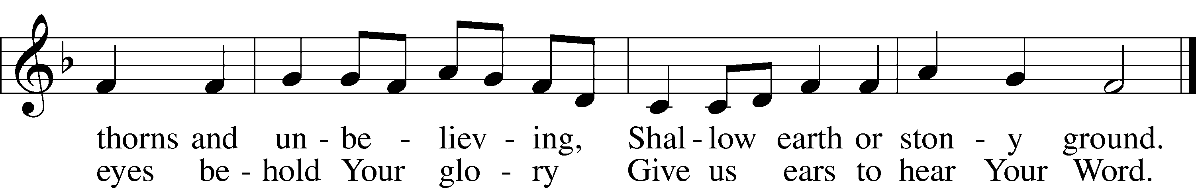
Text: Timothy Dudley-Smith, 1926 Tune: Columbian Harmony, 1825, Cincinnati
Text: © 1997 Hope Publishing Co. Used by permission: LSB Hymn License no. 110002537
Tune: Public domain

SERMON
Please stand as able

PRAYER of the CHURCH
After each Segment:
P Lord, in Your Mercy,
C Hear our Prayer.
After Final Segment:
P Hear us as we pray in His name and as He has taught us:
LORD’S PRAYER
C Our Father who art in heaven,
hallowed be Thy name,
Thy kingdom come,
Thy will be done on earth
as it is in heaven;
give us this day our daily bread;
and forgive us our trespasses
as we forgive those
who trespass against us;
and lead us not into temptation,
but deliver us from evil.
For Thine is the kingdom
and the power and the glory
forever and ever. Amen.

SERVICE of the SACRAMENT
PREFACE LSB 208
P The Lord be with you.
C And also with you.
P Lift up your hearts.
C We lift them to the Lord.
P Let us give thanks to the Lord our God.
C It is right to give Him thanks and praise.
P It is truly good, right, and salutary that we should at all times and in all places give thanks to You, O Lord, holy Father, almighty and everlasting God, for the countless blessings You so freely bestow on us and all creation. Above all, we give thanks for Your boundless love shown to us when You sent Your only-begotten Son, Jesus Christ, into our flesh and laid on Him our sin, giving Him into death that we might not die eternally. Because He is now risen from the dead and lives and reigns to all eternity, all who believe in Him will overcome sin and death and will rise again to new life. Therefore with angels and archangels and with all the company of heaven we laud and magnify Your glorious name, evermore praising You and singing:

SANCTUS LSB 208
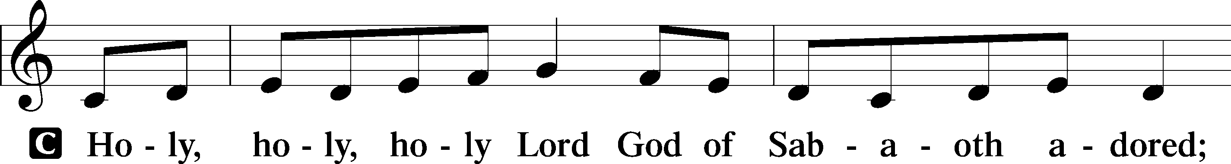
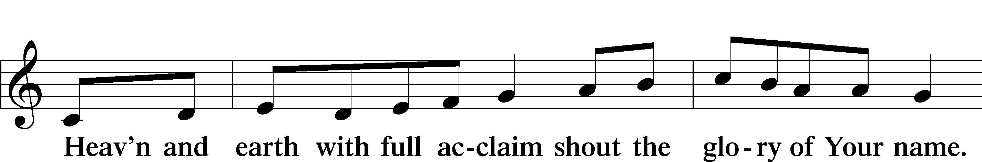
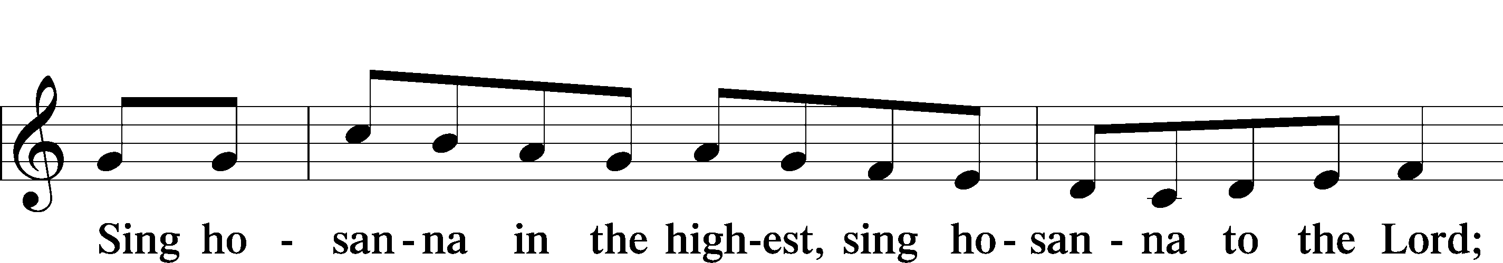

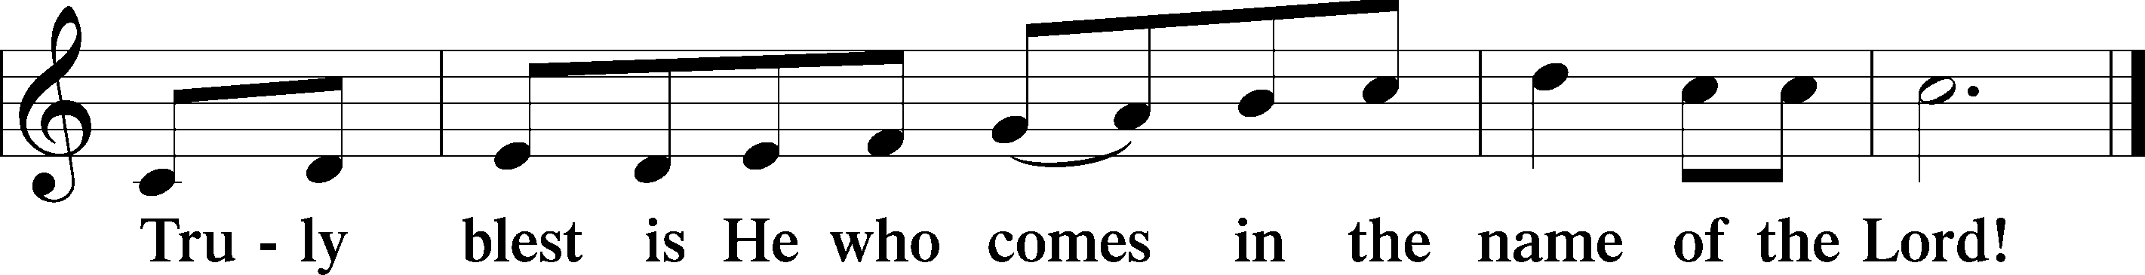

PRAYER OF THANKSGIVING
P Blessed are You, O Lord our God, king of all creation, for You have had mercy on us and given Your only-begotten Son that whoever believes in Him should not perish but have eternal life.

As the glory of Your presence once filled Your ancient temple, so in the incarnation of Your Son, Jesus Christ, You manifested the fullness of Your glory in human flesh.

We give You thanks that in His most Holy Supper You reveal Your glory to us. Grant us faithfully to eat His body and drink His blood so that we may one day behold Your glory face to face.

THE WORDS OF OUR LORD
P Our Lord Jesus Christ, on the night when He was betrayed, took bread, and when He had given thanks, He broke it and gave it to the disciples and said: “Take, eat; this is My T body, which is given for you. This do in remembrance of Me.”
In the same way also, He took the cup after supper, and when He had given thanks, He gave it to them, saying: “Drink of it, all of you; this cup is the New Testament in My T blood, which is shed for you for the forgiveness of sins. This do, as often as you drink it, in remembrance of Me.”

PAX DOMINI
P The peace of the Lord be with you always.
C Amen.
AGNUS DEI
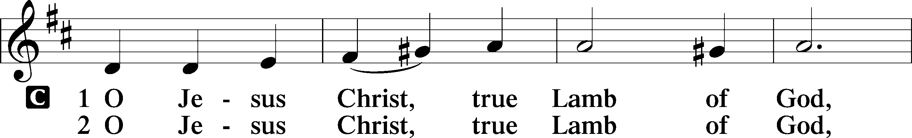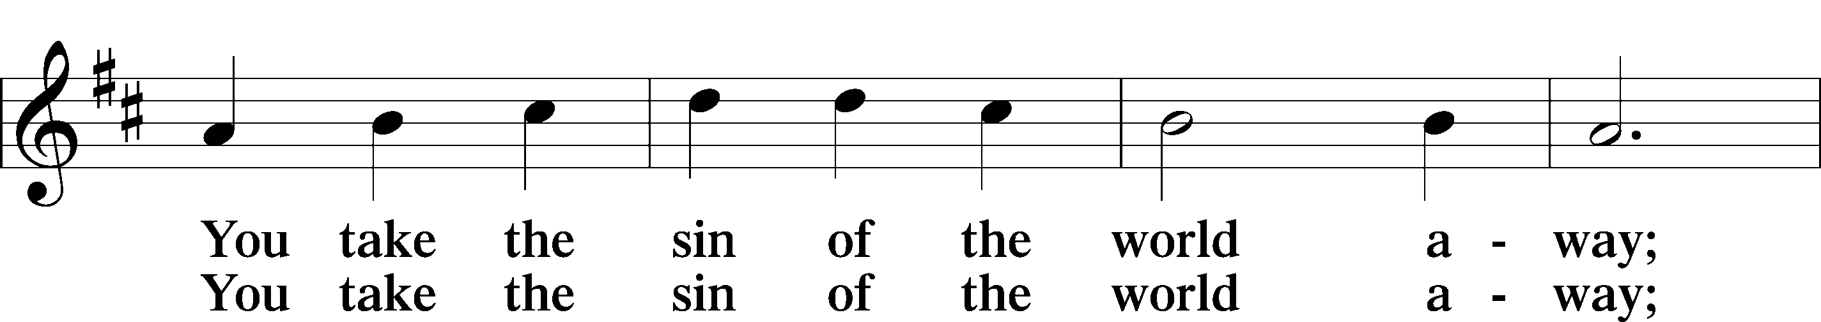
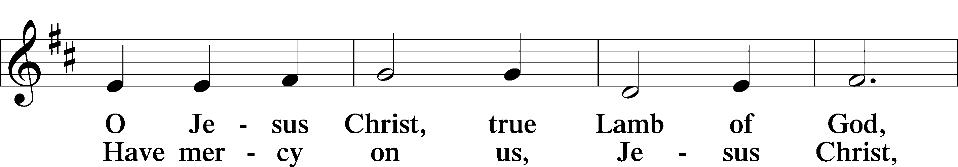
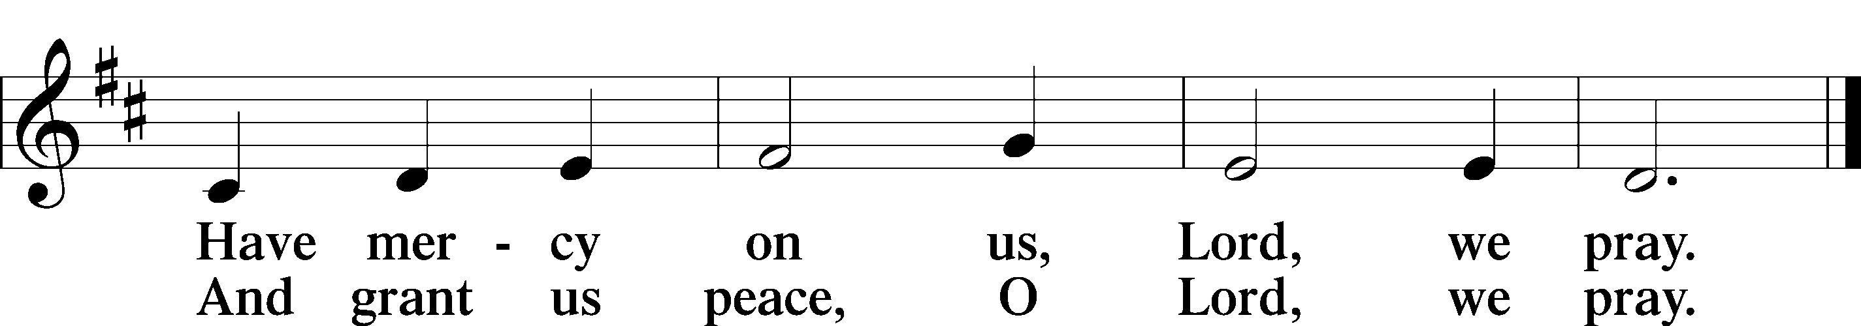

Please be seated
DISTRIBUTION
The pastor and those who assist him receive the body and blood of Christ first, then Communion will be served in a continuous fashion. Households may commune at the same time together. Ushers will help direct you forward via the center aisle; please return to your seats via the side aisles. Gluten-free bread is available for those who need it, as is non-alcoholic grape juice. Simply request either when you come forward to receive Communion.

DISTRIBUTION HYMN
My Hope Is Built on Nothing Less LSB 575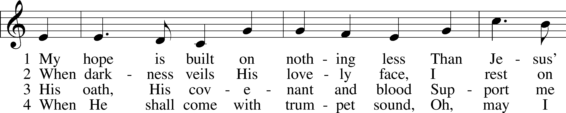
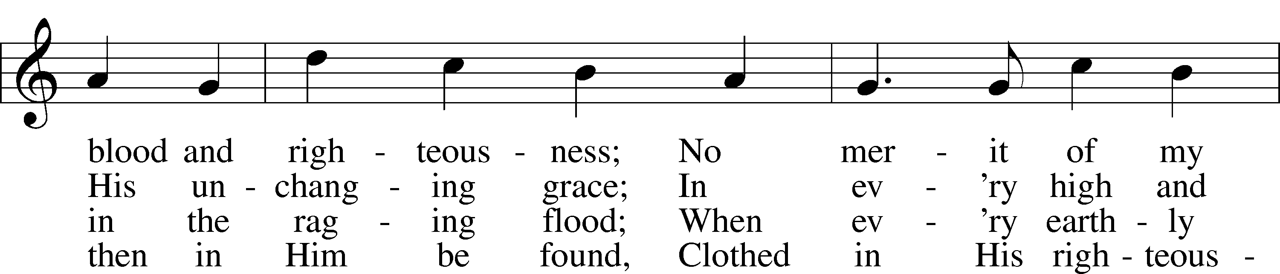
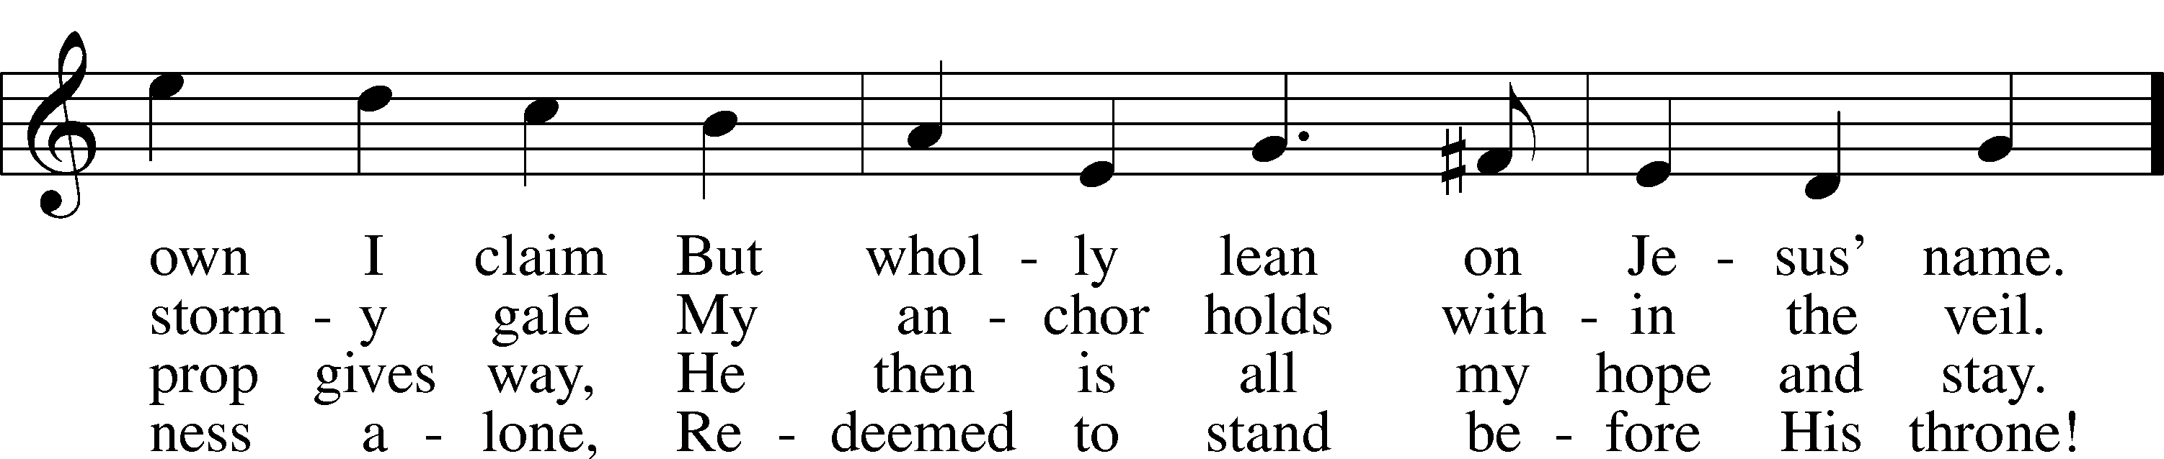
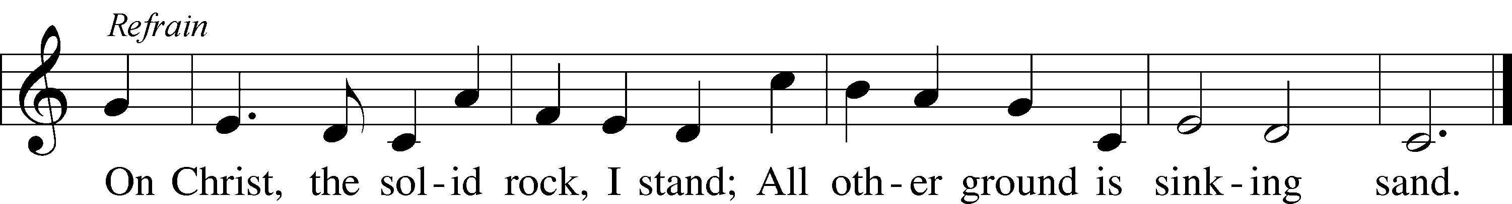
Text: Edward Mote, 1797–1874, alt.
Tune: John Stainer, 1840–1901
Text and tune: Public domain

Please stand as able

THE DISMISSAL
P The body and blood of our Lord Jesus Christ strengthen and preserve you in body and soul
to life everlasting. Depart T in peace.
C Amen.

NUNC DIMITTIS LSB 211
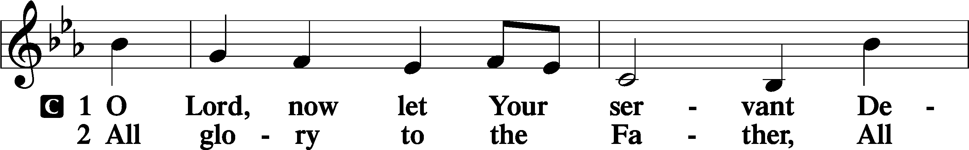
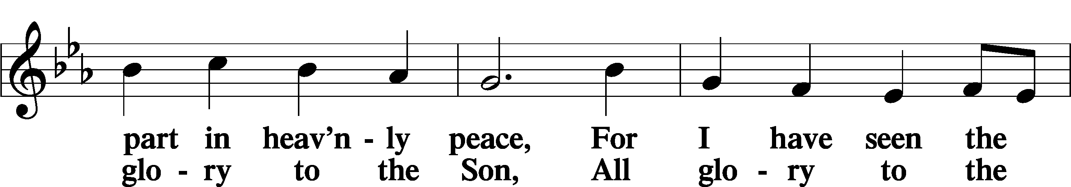
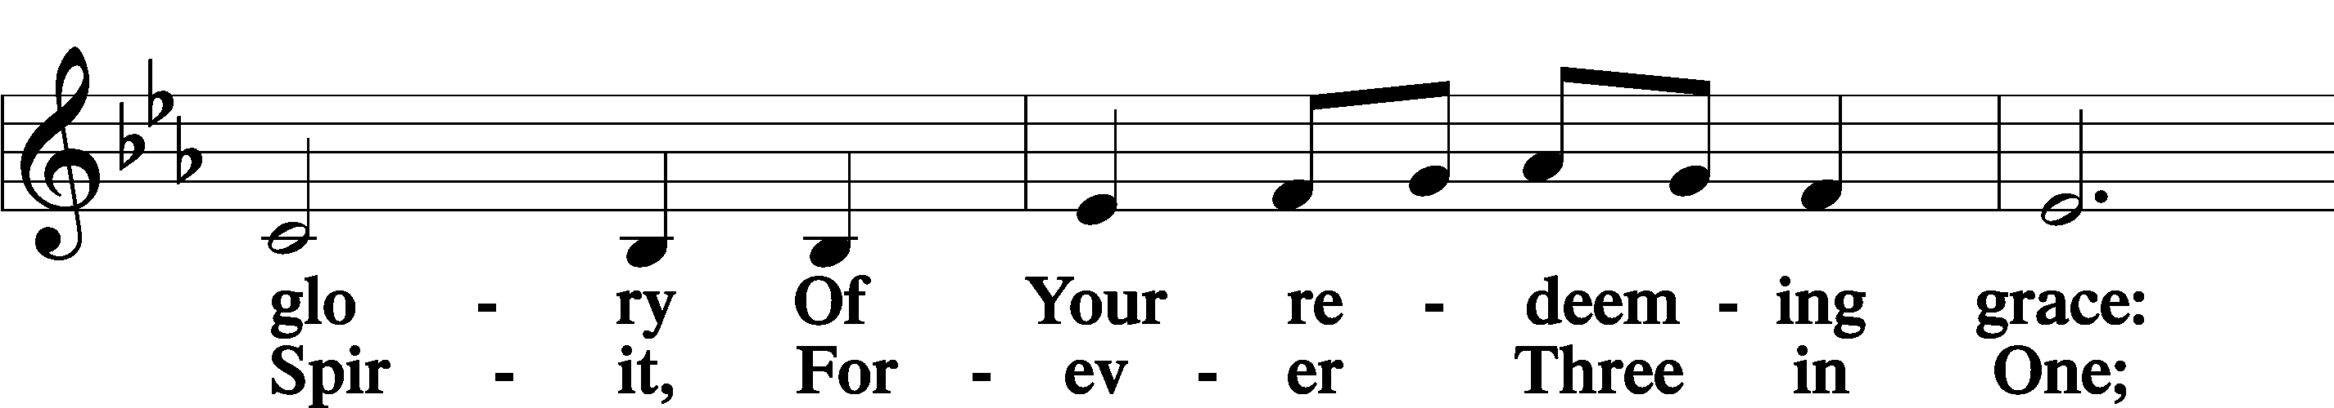
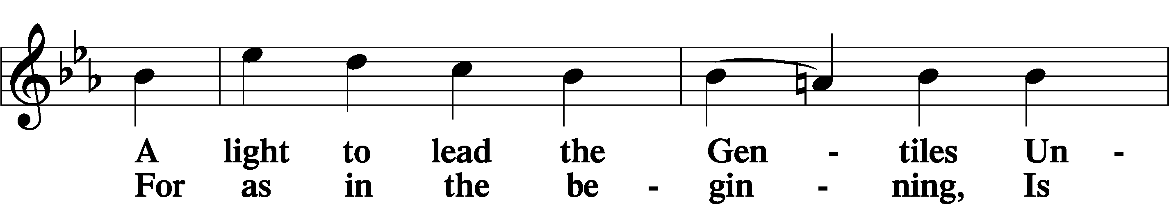
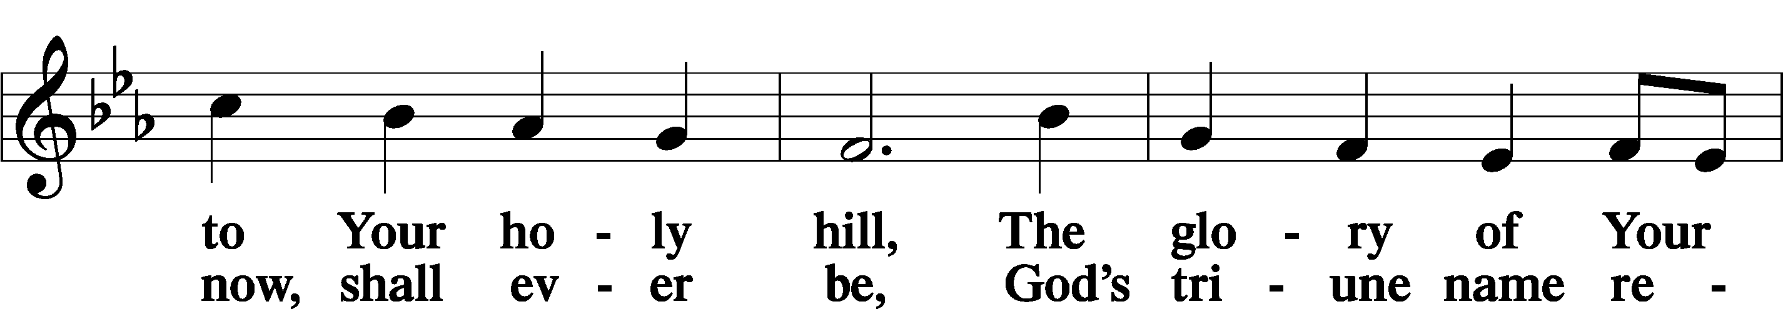
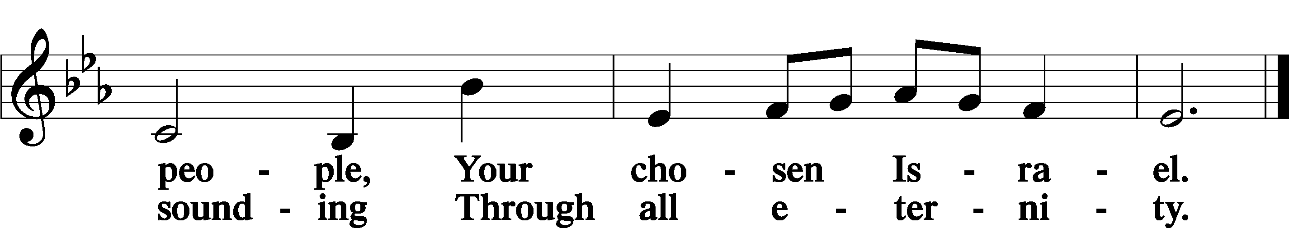

POST COMMUNION COLLECT
P Let us pray.
We give thanks to You, almighty God, that You have refreshed us through this salutary gift, and we implore You that of Your mercy You would strengthen us through the same in faith toward You and in fervent love toward one another; through Jesus Christ, Your Son, our Lord, who lives and reigns with You and the Holy Spirit, one God, now and forever.
C Amen.

BENEDICAMUS LSB 212
P Let us bless the Lord.
C Thanks be to God.
BENEDICTION
P The Lord bless you and keep you.
The Lord make His face shine on you and be gracious to you.
The Lord look upon you with favor and T give you peace.
C Amen.

Please be seated
CLOSING HYMN
Word of God, Come Down on Earth LSB 545
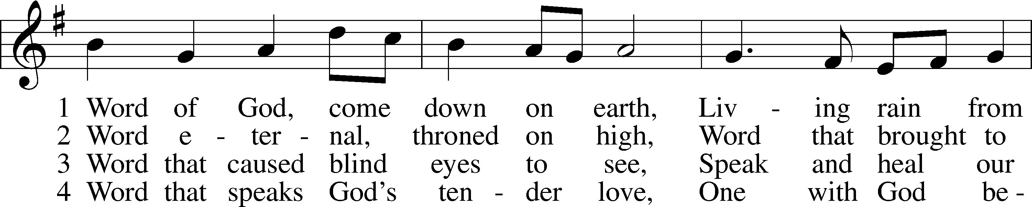
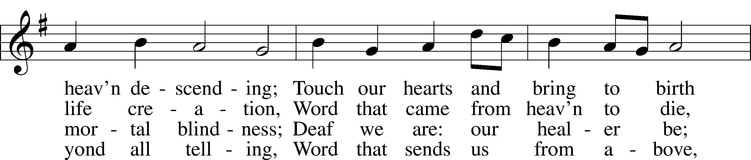
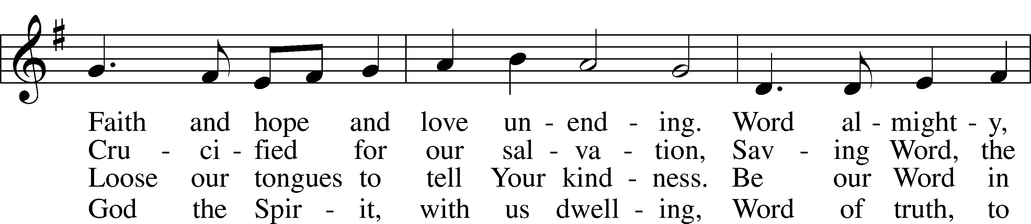
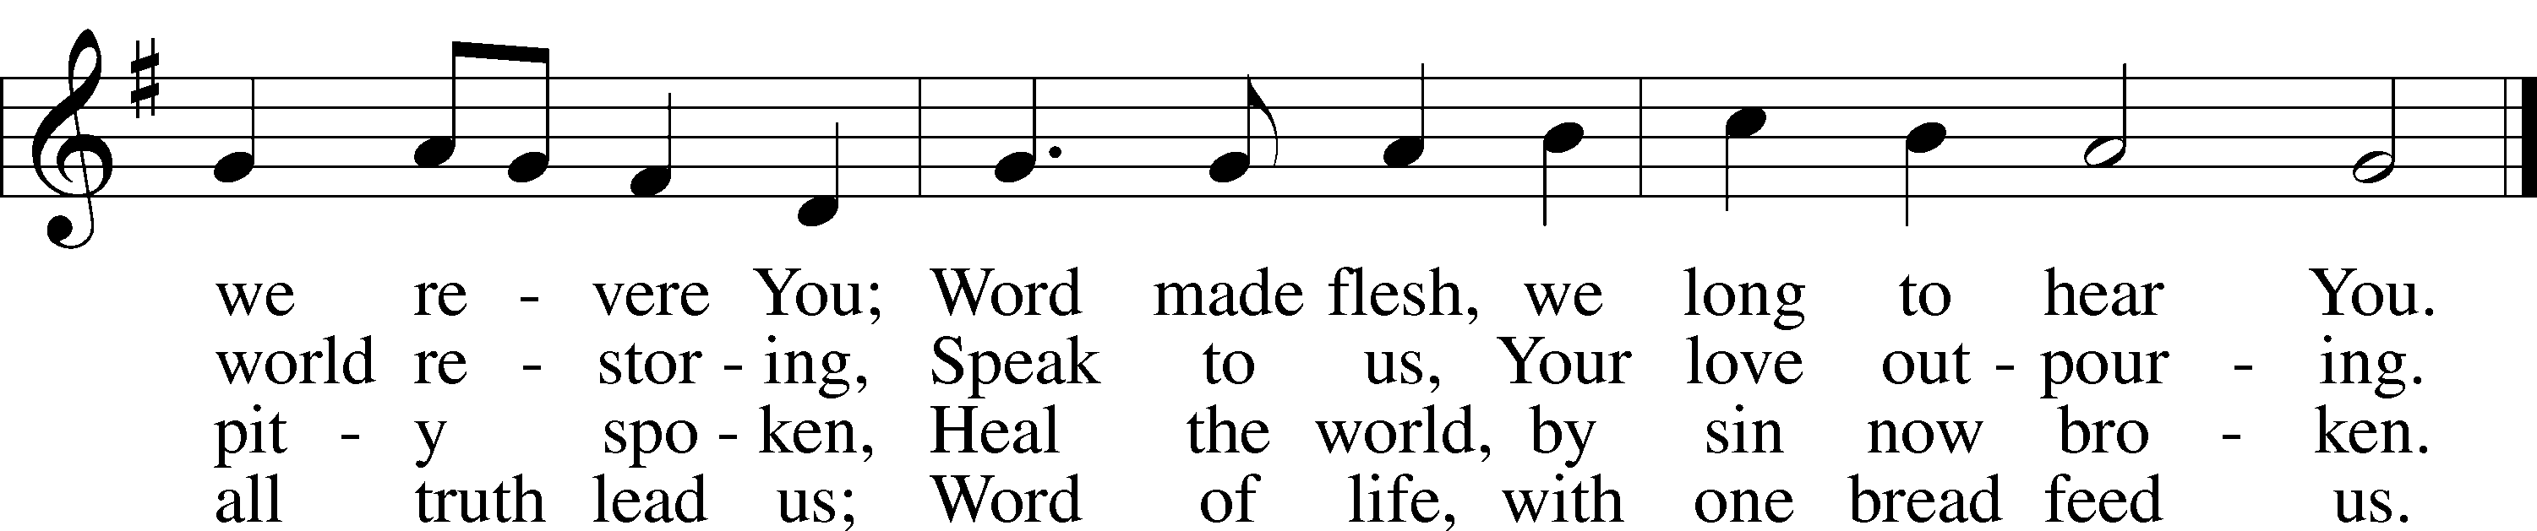
Text: James Quinn, 1919–2010
Tune: Johann Rudolph Ahle, 1625–73, alt.
Text: © 1969 OCP Publications. Used by permission: LSB Hymn License no. 110002537
Tune: Public domain
ANNOUNCEMENTS and SENDING WORDS
P We go to live for Jesus!
C We go to share His love!

Acknowledgments
Unless otherwise indicated, Scripture quotations are from the ESV® Bible (The Holy Bible, English Standard Version®), copyright © 2001 by Crossway, a publishing ministry of Good News Publishers. Used by permission. All rights reserved. Created by Lutheran Service Builde

Next Week’s Readings
Old Testament: Deuteronomy 26:1-11
Epistle: Romans 10:8b-13
Holy Gospel: Luke 4:1-13

SERVING in GODS HOUSE TODAY
Pastor: Rev. Ken Bernthal
Elder: Dave Beyers
Ushers: Linda West, Tom Raithel
Greeters: Beyers Family
Coffee: LWML
Counters: Larry Whitney, Wendell Smith
Altar Care: Linda West
Piano/Organist: Tom/Jean
Children’s Talk: Nancy Ely

PRAYERS
Please contact the office with updates to the prayer list. People will remain on the prayer list for 4 weeks before being removed. If they need to remain on the list, please keep Elaine informed and of any updates. This will help us to have a more accurate list. Thanks for your cooperation.

Those who continue to grieve the passing of loved ones, Family of June Weber
Those with upcoming surgery: Elaine Raschke
Those recovering from surgery:
Those with health concerns: Tiffany Amsdill, Laurie Breen, Hope Buchinger, Jennifer Martin, Leslie Martin, Kay Gregg, Hilda Koch, Eleanor Raether, Beth Smith, and John Stutzman.
Those diagnosed with cancer: Leah Eicher, Rachel Frisch, Joe Gibson, Hope Osantowski, and Maria Freimark .
Those under Hospice Home Care: Ruth Luebs, and Ken Williamson.

BIRTHDAYS: ANNIVERSARIES
3/02 Andrew Appold NONE
3/02 Raymond Mouch
3/03 Ron Kwapis
MESSAGES

ALTAR FLOWERS today are given to the glory of God by Tina VanTil in Memory of her Dad Ron Stier.

NOISY OFFERING: Today we will have a “noisy offering” to benefit the Otsego County Food Pantry. We ask that you consider dropping your pocket change in the buckets on the table where the offering trays are.. All funds collected in these buckets will go to the Otsego County Food Pantry.

MEMBER & GUEST CARDS: If you have not filled out a member/guest card, please take the time to fill one out and place it in the plate behind the back pews in our sanctuary.

WEDNESDAY MORNING BIBLE STUDY, 10:00am in the fellowship hall with Pastor Ken Bernthal.

GREETING CARDS If you are in need of some greeting cards, we carry an array of them in the cabinet in the library. The cost of the cards is posted on the cabinet. The money collected from the cards goes to LWML to help support Missions.

CANCER and FRIENDS SUPPORT GROUP: Will be meeting in March 22nd. We will be having a guest speaker. Please remember Cancer & Friends Support Group is not just for people going through treatment, or survivors, we are also here for caregiver, spouse, children, and friends. There are times when we can all use someone to talk to during those difficult times. If there is any subject you would like to discuss with me you call or text or at 989-350-4391. Hope you will join us.

THIS WEEK AT TRINITY
February 27 Sunday
9:00 am Worship Service - Holy Communion – Rev. Ken Bernthal
Noisy Offering
10:00 am Fellowship & Coffee Hour
10:30 am Sunday Morning Bible Study W/ Dr. Tom Beach

February 28 Monday
7:00 pm Choir

March 1 Tuesday
3:00 pm Heart of The Pines Quilt Guild (Fellowship Hall)
5:30 pm Ladies Get-Togther Dinner at Applebees
6:3 0pm Elders Meeting

March 2 Wednesday
10:00 am Wednesday Morning Bible Study W/ Pastor Ken Bernthal
7:00 pm Ash Wednesday Service
Coffee & pie to follow

March 3 Thursday

March 4 Friday

March 5 Saturday
10:00 am Stephen Ministry Peer Supervision Meeting

March 6 Sunday
9:00 am Worship Service - Holy Communion – Rev. Paul Schneide
10:00 am Fellowship & Coffee Hour
10:30 am Bible Study with Dr. Tom Beach (Tutoring Room)

